
Date:
Pages:

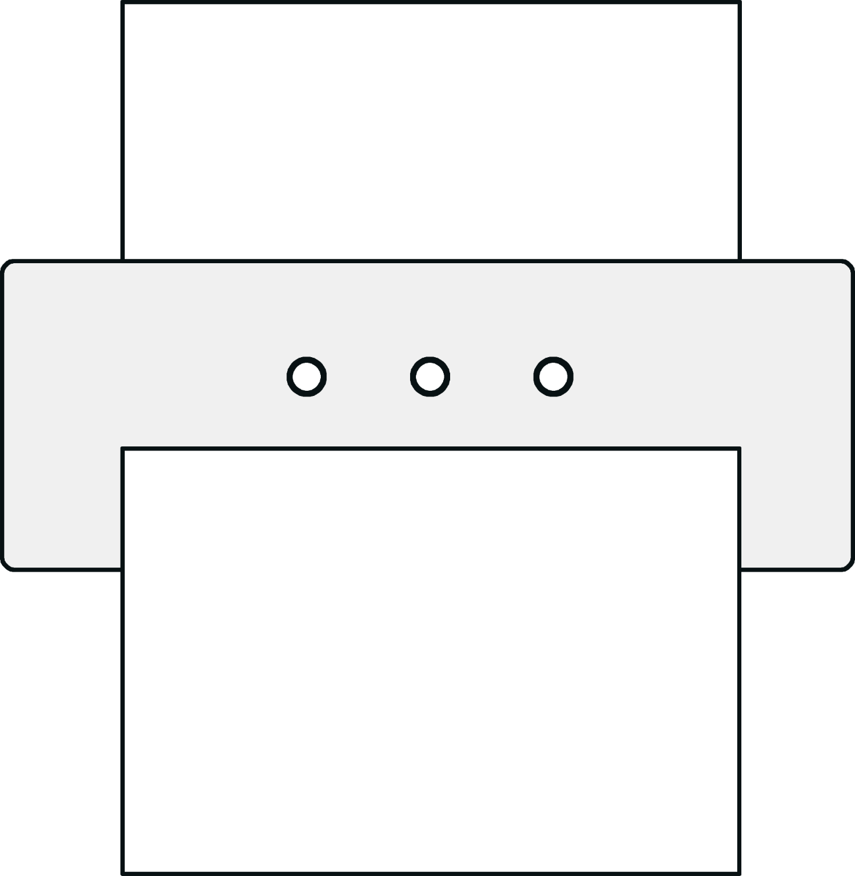
From:
Fax:

To:
Fax:

Message:

